ID: 22424175
COURSE: ASTA 607
COURSE TITLE: COMPUTATIONAL STATISTICS
END OF FIRST SEMESTER EXAMINATION

Question 1
a. The data set contains an equal number of male and female. This dataset makes it easier for comparison and analysis of data. It is also normally distributed with the mean and median approximately the same.
b. input
library(MASS)
data(crabs)
head(crabs) # View first 6 rows
str(crabs) # Check structure
summary(crabs) # Summary statistics
dim(crabs) # Number of rows

Output
library(MASS)
> data(crabs)
> head(crabs) # View first 6 rows
sp sex index FL RW CL CW BD
1 B M 1 8.1 6.7 16.1 19.0 7.0
2 B M 2 8.8 7.7 18.1 20.8 7.4
3 B M 3 9.2 7.8 19.0 22.4 7.7
4 B M 4 9.6 7.9 20.1 23.1 8.2
5 B M 5 9.8 8.0 20.3 23.0 8.2
6 B M 6 10.8 9.0 23.0 26.5 9.8
> str(crabs) # Check structure
'data.frame': 200 obs. of 8 variables:
$ sp : Factor w/ 2 levels "B","O": 1 1 1 1 1 1 1 1 1 1 ...
$ sex : Factor w/ 2 levels "F","M": 2 2 2 2 2 2 2 2 2 2 ...
$ index: int 1 2 3 4 5 6 7 8 9 10 ...
$ FL : num 8.1 8.8 9.2 9.6 9.8 10.8 11.1 11.6 11.8 11.8 ...
$ RW : num 6.7 7.7 7.8 7.9 8 9 9.9 9.1 9.6 10.5 ...
$ CL : num 16.1 18.1 19 20.1 20.3 23 23.8 24.5 24.2 25.2 ...
$ CW : num 19 20.8 22.4 23.1 23 26.5 27.1 28.4 27.8 29.3 ...
$ BD : num 7 7.4 7.7 8.2 8.2 9.8 9.8 10.4 9.7 10.3 ...

c. Input
table(crabs$sp, crabs$sex)
Output
F M
B 50 50
O 50 50

d. Input
tab <- table(crabs$sp, crabs$sex)
tab
# Bar chart
barplot(tab,
beside = TRUE,
col = c("skyblue", "orange"),
legend = rownames(tab),
xlab = "Sex",
ylab = "Frequency",
main = "Species by Sex Composition in Crabs Dataset")
Output
tab <- table(crabs$sp, crabs$sex)
> tab

F M
B 50 50
O 50 50
> # Bar chart
> barplot(tab,
+ beside = TRUE,
+ col = c("skyblue", "orange"),
+ legend = rownames(tab),
+ xlab = "Sex",
+ ylab = "Frequency",
+ main = "Species by Sex Composition in Crabs Dataset")

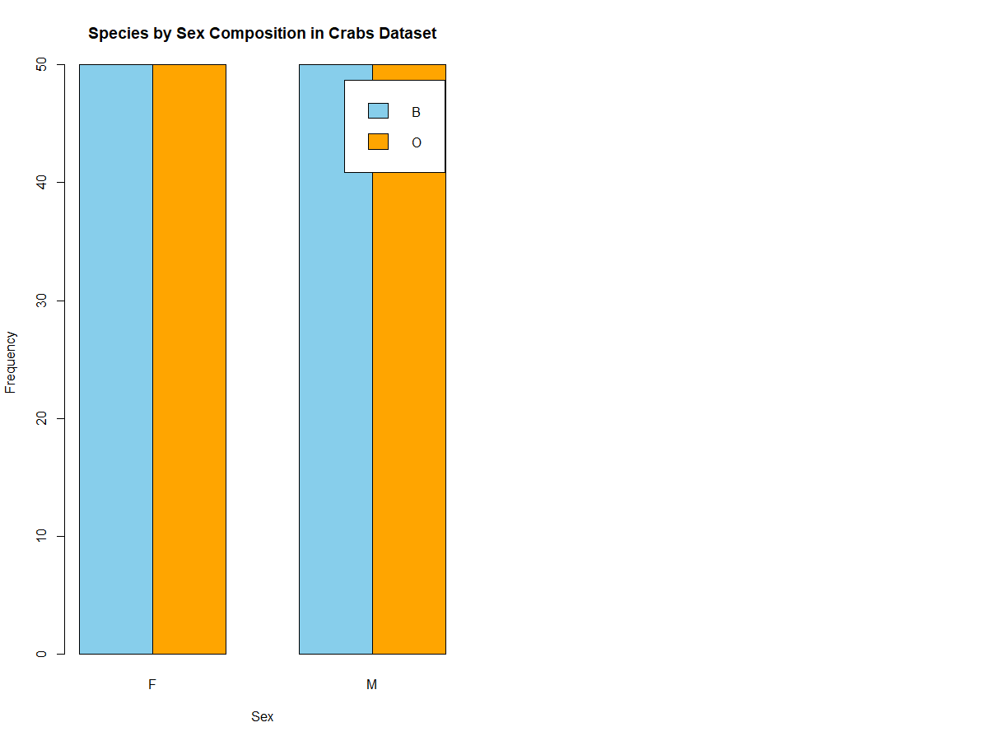

The dataset contains equal numbers of:
- Blue and Orange species
- Male and Female crabs
the bar chart and mosaic plot will show equal proportions across all groups.

QUESTION 2
- Input
# Side-by-side boxplot of body depth (BD)
boxplot(BD ~ group, data = crabs,
col = c("skyblue","lightblue","orange","pink"),
xlab = "Species and Sex",
ylab = "Body Depth (BD)",
main = "Body Depth by Species and Sex")
# Mean
aggregate(BD ~ group, data = crabs, mean)

# Median
aggregate(BD ~ group, data = crabs, median)

# Standard deviation
aggregate(BD ~ group, data = crabs, sd)
# Boxplot statistics
boxplot(BD ~ group, data = crabs, plot = TRUE,
col = c("skyblue","lightblue","orange","pink"),
xlab = "Species and Sex", ylab = "Body Depth (BD)",
main = "Body Depth by Species and Sex")

# Extract outlier values
- Input
<- boxplot.stats(crabs$BD[crabs$group=="B.F"])$out
# Outliers in Blue Females

Output
# Side-by-side boxplot of body depth (BD)
> boxplot(BD ~ group, data = crabs,
+ col = c("skyblue","lightblue","orange","pink"),
+ xlab = "Species and Sex",
+ ylab = "Body Depth (BD)",
+ main = "Body Depth by Species and Sex")

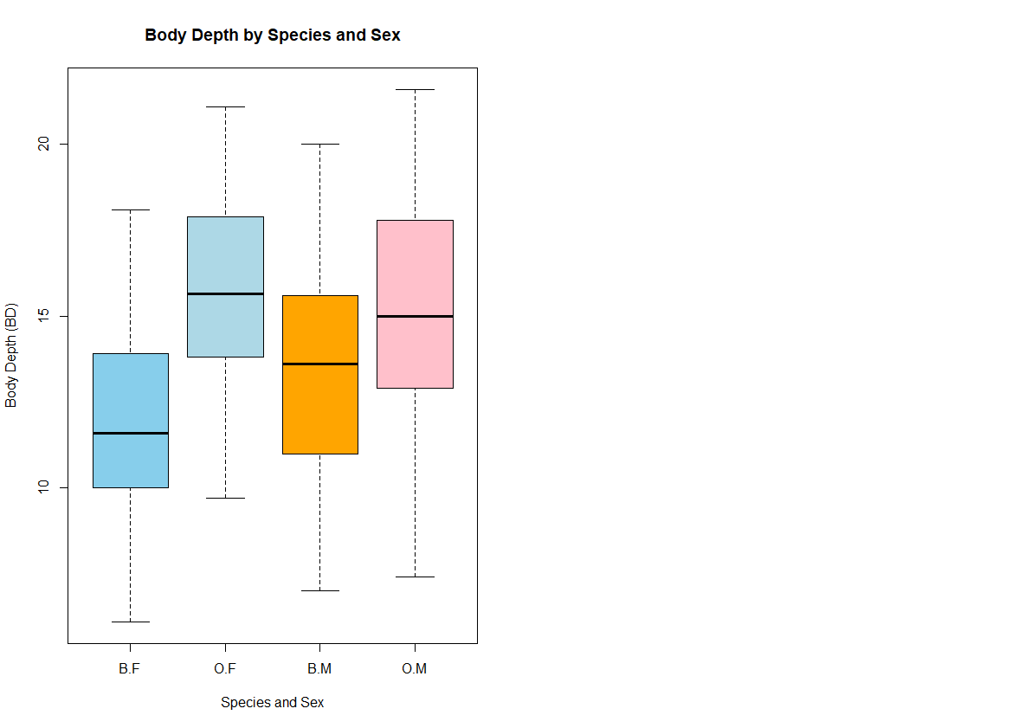

> # Mean
> aggregate(BD ~ group, data = crabs, mean)
group BD
1 B.F 11.816
2 O.F 15.632
3 B.M 13.350
4 O.M 15.324
>
> # Median
> aggregate(BD ~ group, data = crabs, median)
group BD
1 B.F 11.60
2 O.F 15.65
3 B.M 13.60
4 O.M 15.00

> # Standard deviation
> aggregate(BD ~ group, data = crabs, sd)
group BD
1 B.F 2.752465
2 O.F 2.752620
3 B.M 3.199888
4 O.M 3.527187
> # Boxplot statistics
> boxplot(BD ~ group, data = crabs, plot = TRUE,
+ col = c("skyblue","lightblue","orange","pink"),
+ xlab = "Species and Sex", ylab = "Body Depth (BD)",
+ main = "Body Depth by Species and Sex")
>
> # Extract outlier values
b. Output
<- boxplot.stats(crabs$BD[crabs$group=="B.F"])$out
> b # Outliers in Blue Females
numeric(0)

Question 3
Input
# Set up plotting area for 2 histograms side by side
par(mfrow = c(1, 2)) # 1 row, 2 columns

# Histogram for Blue crabs
hist(crabs$CL[crabs$sp == "B"],
main = "Carapace Length - Blue Crabs",
xlab = "Carapace Length (CL)",
col = "skyblue",
border = "white",
breaks = 10)

# Histogram for Orange crabs
hist(crabs$CL[crabs$sp == "O"],
main = "Carapace Length - Orange Crabs",
xlab = "Carapace Length (CL)",
col = "orange",
border = "white",
breaks = 10)

# Summary statistics by species
aggregate(CL ~ sp, data = crabs, summary)

# Standard deviation
aggregate(CL ~ sp, data = crabs, sd)

# install.packages("e1071")
library(e1071)

# Skewness
skewness(crabs$CL[crabs$sp=="B"])
skewness(crabs$CL[crabs$sp=="O"])

Output
# Set up plotting area for 2 histograms side by side
> par(mfrow = c(1, 2)) # 1 row, 2 columns
>
> # Histogram for Blue crabs
> hist(crabs$CL[crabs$sp == "B"],
+ main = "Carapace Length - Blue Crabs",
+ xlab = "Carapace Length (CL)",
+ col = "skyblue",
+ border = "white",
+ breaks = 10)
>
> # Histogram for Orange crabs
> hist(crabs$CL[crabs$sp == "O"],
+ main = "Carapace Length - Orange Crabs",
+ xlab = "Carapace Length (CL)",
+ col = "orange",
+ border = "white",
+ breaks = 10)
>
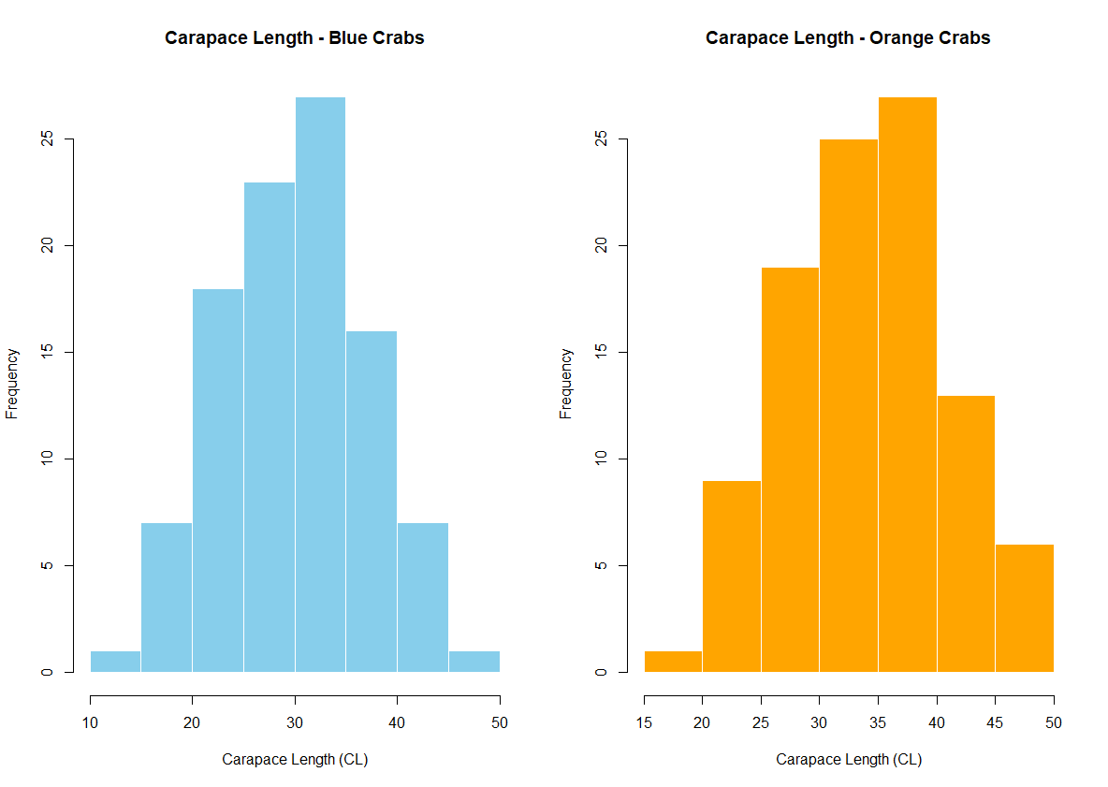

> # Summary statistics by species
> aggregate(CL ~ sp, data = crabs, summary)
sp CL.Min. CL.1st Qu. CL.Median CL.Mean CL.3rd Qu. CL.Max.
1 B 14.700 24.850 30.100 30.058 34.600 47.100
2 O 16.700 29.200 34.550 34.153 39.400 47.600
>
> # Standard deviation
> aggregate(CL ~ sp, data = crabs, sd)
sp CL
1 B 6.902703
2 O 6.764262

> # Skewness
> skewness(crabs$CL[crabs$sp=="B"])
[1] 0.02571518
> skewness(crabs$CL[crabs$sp=="O"])
[1] -0.1536776
b.
Blue Crabs (B)
- Modality: Unimodal (single clear peak around 15–16)
- Skewness: Slight right skew (longer tail towards higher carapace lengths)
- Distribution: Symmetric-ish around median, but a few larger crabs pull the mean slightly higher.
Orange Crabs (O)
- Modality: Also unimodal (peak around 14–15)
- Skewness: Slight right skew, similar to Blue, but slightly less pronounced
- Distribution: More concentrated around median, slightly shorter tail than Blue.

Question 4
a. Input
ggplot(means_long, aes(x = Measurement, y = MeanValue, fill = Group)) +
geom_bar(stat = "identity", position = position_dodge()) +
scale_fill_manual(values = c("skyblue", "lightblue", "orange", "pink"),
labels = c("Blue-Female", "Blue-Male", "Orange-Female", "Orange-Male")) +
labs(title = "Mean Morphological Measurements by Species and Sex",
x = "Morphological Measurement",
y = "Mean Value",
fill = "Species and Sex") +
theme_minimal()

Output
library(MASS)
> library(ggplot2)
> library(reshape2) # for reshaping data
Warning message:
package ‘reshape2’ was built under R version 4.3.3
>
> data(crabs)
>
> # Compute mean of morphological measurements by species and sex
> means_df <- aggregate(cbind(FL, RW, CL, CW, BD) ~ sp + sex, data = crabs, mean)

> # Reshape from wide to long format for ggplot2
> means_long <- melt(means_df, id.vars = c("sp", "sex"),
+ variable.name = "Measurement",
+ value.name = "MeanValue")
>
> # Create a combined group variable for plotting
> means_long$Group <- interaction(means_long$sp, means_long$sex)
>
> ggplot(means_long, aes(x = Measurement, y = MeanValue, fill = Group)) +
+ geom_bar(stat = "identity", position = position_dodge()) +
+ scale_fill_manual(values = c("skyblue", "lightblue", "orange", "pink"),
+ labels = c("Blue-Female", "Blue-Male", "Orange-Female", "Orange-Male")) +
+ labs(title = "Mean Morphological Measurements by Species and Sex",
+ x = "Morphological Measurement",
+ y = "Mean Value",
+ fill = "Species and Sex") +
+ theme_minimal()

# Compute mean for all five measurements by species and sex
> aggregate(cbind(FL, RW, CL, CW, BD) ~ sp + sex, data = crabs, mean)
sp sex FL RW CL CW BD
1 B F 13.270 12.138 28.102 32.624 11.816
2 O F 17.594 14.836 34.618 39.036 15.632
3 B M 14.842 11.718 32.014 36.810 13.350
4 O M 16.626 12.262 33.688 37.188 15.324

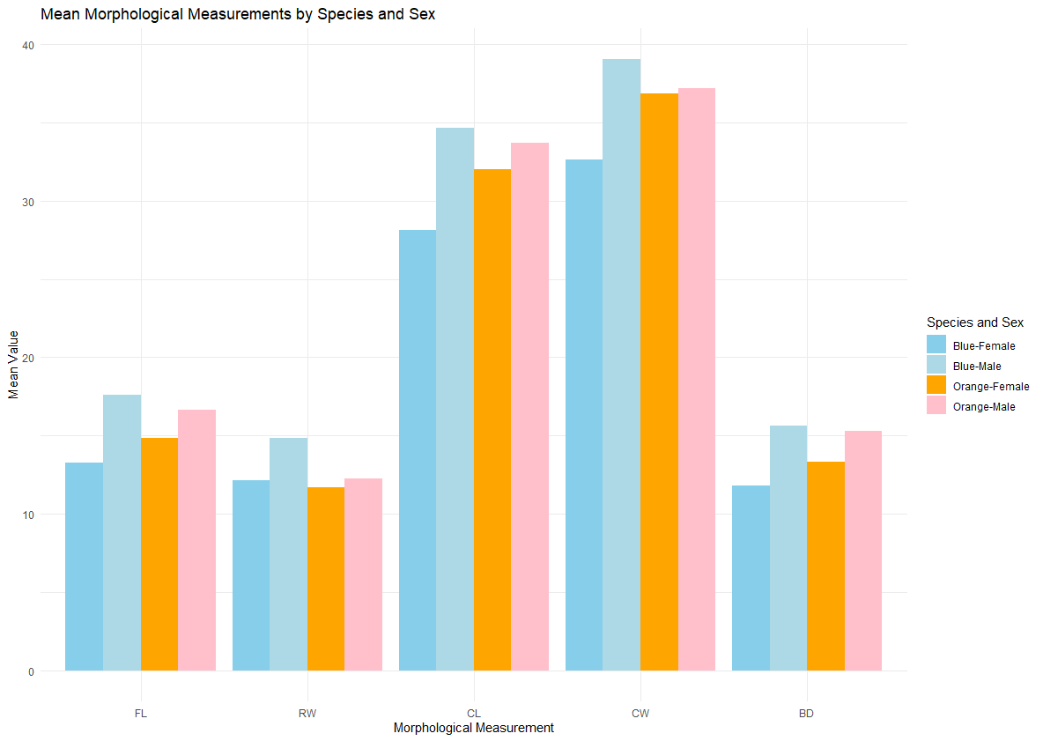

Question 5
Input
# Mean by species
species_means <- aggregate(cbind(FL, RW, CL, CW, BD) ~ sp,
data = crabs, mean)

species_means

# Difference between Blue and Orange means
diffs <- abs(species_means[1, -1] - species_means[2, -1])
diffs

# Standard deviations for each measurement
sds <- sapply(crabs[, c("FL","RW","CL","CW","BD")], sd)
sds

pairs(crabs[, c("FL", "RW", "CL", "CW", "BD")],
main = "Scatterplot Matrix of Morphological Measurements")

# Define colors by species
cols <- ifelse(crabs$sp == "B", "blue", "orange")

pairs(crabs[, c("FL", "RW", "CL", "CW", "BD")],
col = cols,
pch = 19,
main = "Scatterplot Matrix of Measurements (Blue vs Orange)")

library(psych)

pairs.panels(crabs[, c("FL", "RW", "CL", "CW", "BD")],
method = "pearson",
hist.col = "lightgray",
ellipses = TRUE,
main = "Scatterplot Matrix with Correlations")
Output
# Mean by species
> species_means <- aggregate(cbind(FL, RW, CL, CW, BD) ~ sp,
+ data = crabs, mean)
> species_means
sp FL RW CL CW BD
1 B 14.056 11.928 30.058 34.717 12.583
2 O 17.110 13.549 34.153 38.112 15.478
> # Difference between Blue and Orange means
> diffs <- abs(species_means[1, -1] - species_means[2, -1])
> diffs
FL RW CL CW BD
1 3.054 1.621 4.095 3.395 2.895
> # Standard deviations for each measurement
> sds <- sapply(crabs[, c("FL","RW","CL","CW","BD")], sd)
> sds
FL RW CL CW BD
3.495325 2.573340 7.118983 7.871955 3.424772
> pairs(crabs[, c("FL", "RW", "CL", "CW", "BD")],
+ main = "Scatterplot Matrix of Morphological Measurements")
> # Define colors by species
> cols <- ifelse(crabs$sp == "B", "blue", "orange")
>
> pairs(crabs[, c("FL", "RW", "CL", "CW", "BD")],
+ col = cols,
+ pch = 19,
+ main = "Scatterplot Matrix of Measurements (Blue vs Orange)")

> # Install if needed
> # install.packages("psych")
> library(psych)

> pairs.panels(crabs[, c("FL", "RW", "CL", "CW", "BD")],
+ method = "pearson",
+ hist.col = "lightgray",
+ ellipses = TRUE,
+ main = "Scatterplot Matrix with Correlations")
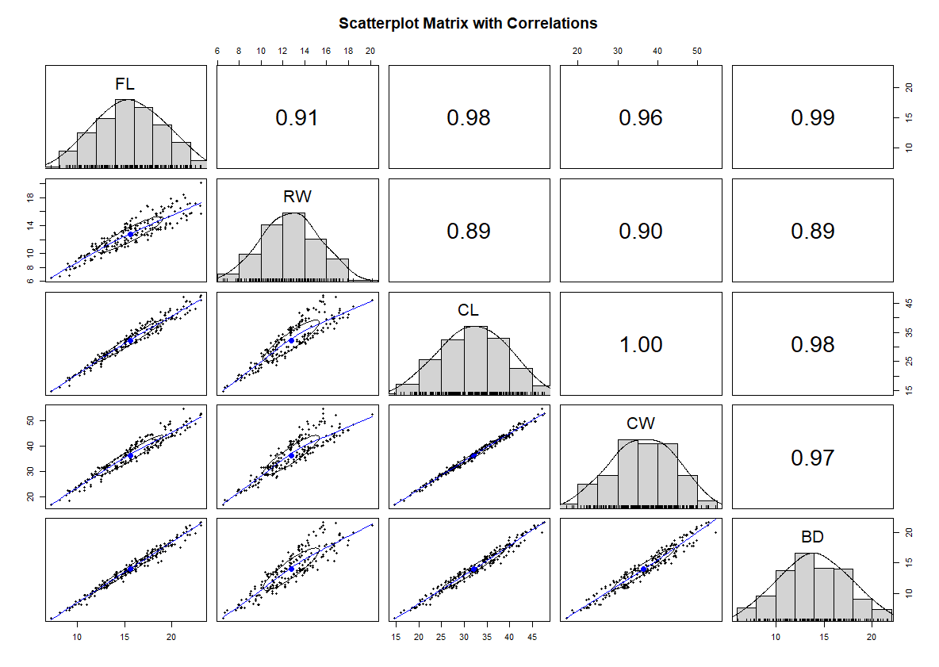

From the scatterplot matrix, you will typically observe:
- Strong positive correlations among all five measurements
- Larger crabs tend to be large in all dimensions
- Near-linear relationships between length, width, and depth variables
- Possible slight clustering by species

Question 6
Statistical Analysis of Morphological Variation in the Crabs Dataset
1. Introduction
This report presents an exploratory statistical analysis of the crabs dataset. The dataset contains 200 observations of crabs classified by species (Blue “B” and Orange “O”) and sex (Male “M” and Female “F”). For each crab, five continuous morphological measurements were recorded:
- Frontal lobe size (FL)
- Rear width (RW)
- Carapace length (CL)
- Carapace width (CW)
- Body depth (BD)
The primary objective of this analysis is to examine the composition of the groups, explore distributional characteristics, compare central tendency and variability across groups, and assess which measurements best distinguish species.

2. Group Composition
Frequency tables and a mosaic plot of species by sex reveal a perfectly balanced design:
- 100 Blue crabs and 100 Orange crabs
- 100 Males and 100 Females
- 50 observations in each of the four species–sex combinations
. This balanced structure strengthens the validity of comparative statistical analysis because group differences are not confounded by unequal sample sizes.

3. Distribution of Carapace Length by Species
Histograms of carapace length (CL) were constructed separately for blue and orange crabs.
Both species exhibit:
- Unimodal distributions
- Approximately symmetric shapes
- Slight positive (right) skewness
The Blue species distribution is centered slightly to the right of the orange species, indicating that blue crabs tend to have marginally larger carapace lengths. The right skewness suggests the presence of a small number of relatively large crabs in both species, though no extreme outliers dominate the distributions.
Overall, the two distributions are similar in shape and spread, differing primarily in location (central tendency).

4. Body Depth Across Species and Sex
Side-by-side boxplots of body depth (BD) for the four species–sex groups provide insight into both central tendency and variability.
The boxplots reveal:
- Males consistently have larger body depth than females within each species.
- Blue crabs tend to have slightly greater body depth than orange crabs.
- Variability (as measured by interquartile range and standard deviation) is fairly similar across groups.
- No extreme outliers are observed.
Numerical summaries confirm these visual impressions:
- Male groups have higher means and medians than female groups.
- Standard deviations are comparable across groups.
- Body depth exhibits the smallest overall standard deviation among the five measurements, indicating relatively low variability.
These findings suggest that sex plays a strong role in determining body depth, with males being systematically larger.

5. Mean Morphological Measurements by Species and Sex
A grouped bar chart displaying mean values for FL, RW, CL, CW, and BD across the four groups reveals consistent structural patterns:
- For every measurement, males exceed females within each species.
- Blue crabs generally show slightly larger measurements than orange crabs.
- The differences are consistent across all morphological dimensions.
The parallel nature of the bar heights across measurements suggests that the morphological traits scale together — larger crabs are larger in all dimensions.

6. Species Differences and Variability
To determine which measurement best distinguishes species, mean differences between blue and orange crabs were examined.
Rear width (RW) shows the largest mean difference between species, indicating that this measurement provides the strongest separation between blue and orange crabs.
In contrast, body depth (BD) shows the least overall variability. This indicates that although BD varies between sex groups, it is relatively stable compared to the other measurements.
Thus:
- Greatest species difference: Rear Width (RW)
- Least overall variation: Body Depth (BD)
Rear width may therefore be the most informative measurement for species classification.

7. Multivariate Relationships
A scatterplot matrix of the five measurements reveals:
- Strong positive linear relationships among all variables.
- High correlations between length, width, and depth measures.
- Clear size scaling: crabs that are large in one dimension tend to be large in others.
The near-linear relationships suggest substantial multicollinearity among measurements. These strong correlations imply that the dataset is well-suited for multivariate techniques such as principal component analysis or discriminant analysis.

8. Overall Interpretation
The analysis of the crabs dataset reveals a coherent biological pattern:
- The dataset is perfectly balanced across species and sex.
- Both species exhibit similar distributional shapes, with slight right skewness.
- Sex differences are more pronounced than species differences, particularly in body depth and other size-related measures.
- Rear width provides the strongest separation between species.
- Body depth shows the least variability across all crabs.
- All morphological measurements are strongly positively correlated, indicating consistent body scaling.
Taken together, these findings suggest that morphological variation in this dataset is primarily structured by overall body size, with systematic differences attributable to sex and more subtle differences attributable to species.

